How recover the Linux Private key if user lose by mistakenly

Create the Linux Instance as ***Linux_Prod_Server***

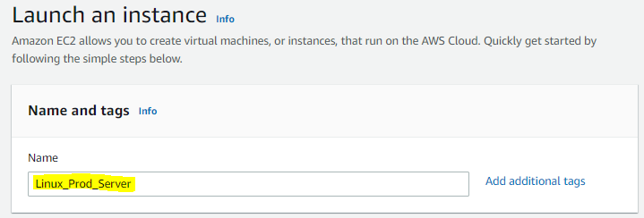

Select the Applications & OS Images (Amazon Machine Name)

Select the ***Red Hat Enterprises Linux 8***

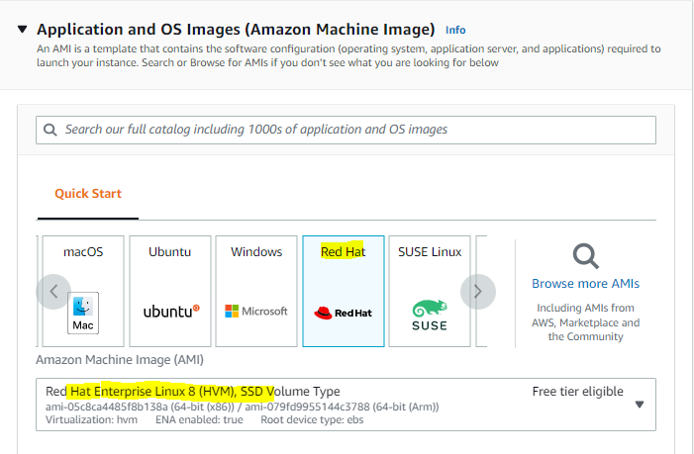

Create a new key as GoodKey with .ppk format

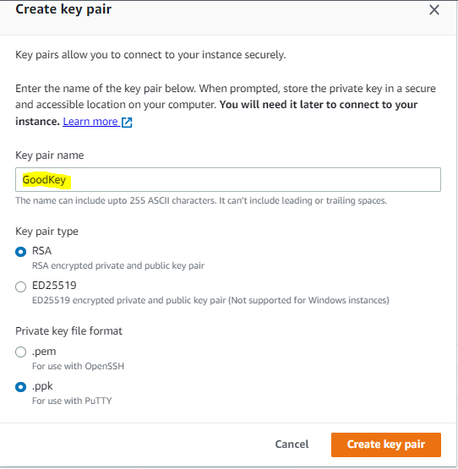

Now save the **GoodKey** in safe place

Now Select the Subnet – ***ap_south_1a***

Security Group – ***Launch-Wizard-2***

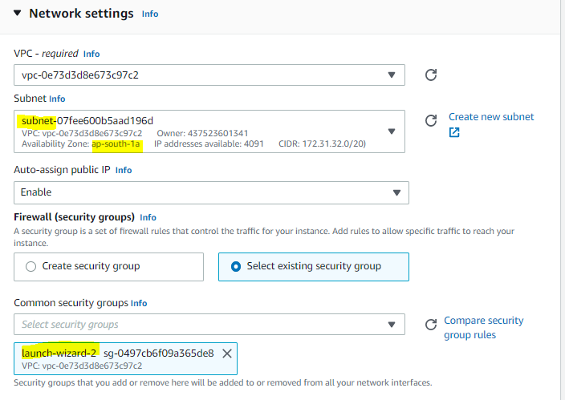

Launch the Red Hat Instance – Wia Putty

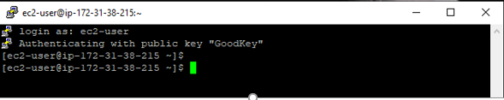

Check the Instance Directory & Private key in Linux Prod machine

# pwd

# cat /home/ec2-user/.ssh/authorized_keys

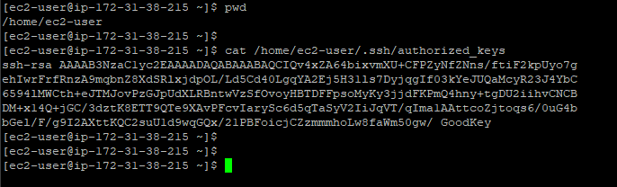

Now we need some information of Linux_Prod_Server if the key loosed

1. **Copy the System Name: -**  /dev/sda1
2. **Copy the AMI id:** - ami-05c8ca4485f8b138a
3. **Copy the subnet mask:** - ap_south_1a
4. **Copy the Security Group:** - Launch-Wizard-2

Make sure when you recover the existing Linux machine You need system name, Subnet mask & Security group and remember the AMI Id as when you create the temp Linux Instance the AMI ID will never take same.

I have created the one directory in Linux_Prod_Server with root user for make sure we can recover the Linux_Prod_Server when the key loses

# mkdir appdir

# ll -a

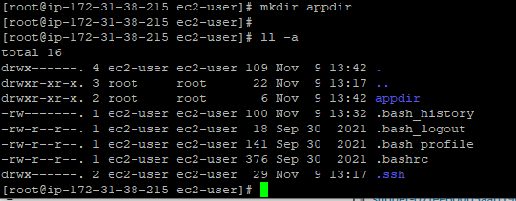

Now I can delete the GoodKey from the keys- by mistaken

Now We need to recover the instance, we create the Temp Linux Machine for recover the ***Linux_Prod_Server***

Create the Temp Linux instance with ***Linux_Temp_Server***

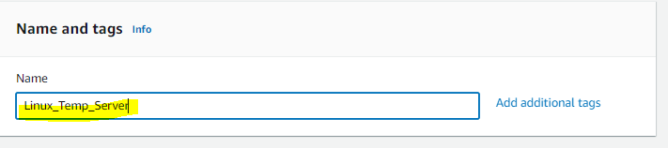

Now we have chosen the Different AMI id but same Subnet & Security group.

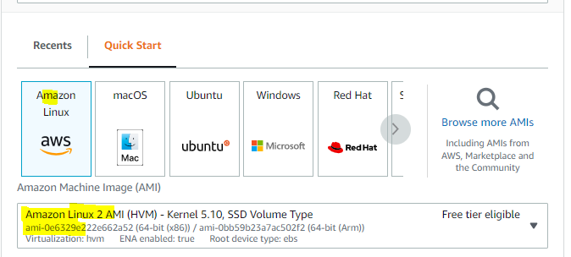

Now we can create the new key as **RecoverKey**

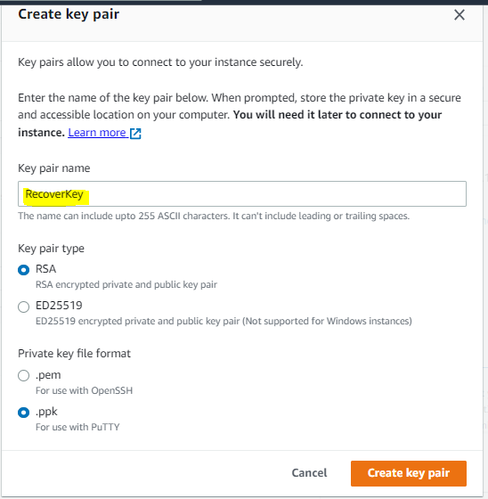

Select the same Subnet - ***ap_south_1a*** & Security group - *Launch-Wizard-2* & Launch the Instance

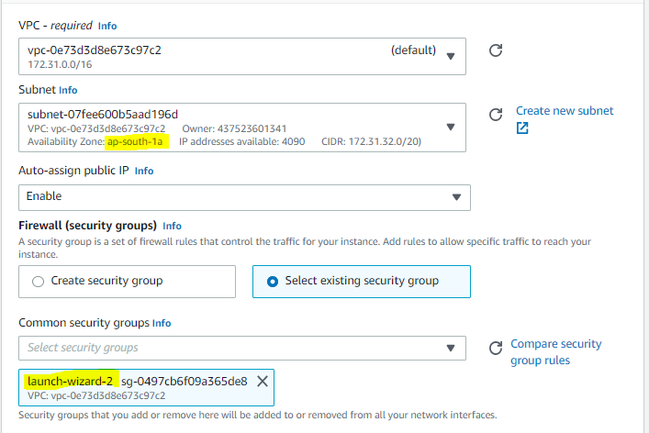

Now go to Volumes & gives them name for understood the Recover Instance & Prod Instance respectively

* Linux_Prod_Server – ***Prod_Linux***
* Linux_Temp_Server- ***Recover_Linux***

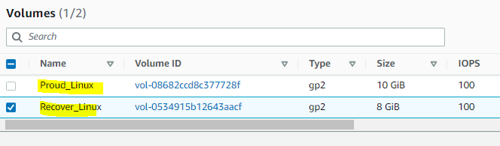

Now Login the Linux_Temp_Server wai putty

We can see the directory & private key in ***Linux_Temp_Server***

# pwd

# cat /home/ec2-user/.ssh/authorized_keys

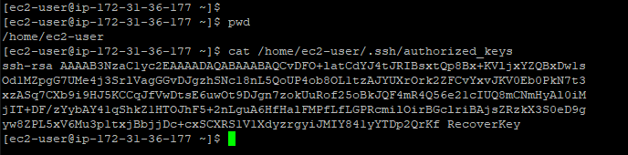

# sudo –s

# lsblk

# ll -a

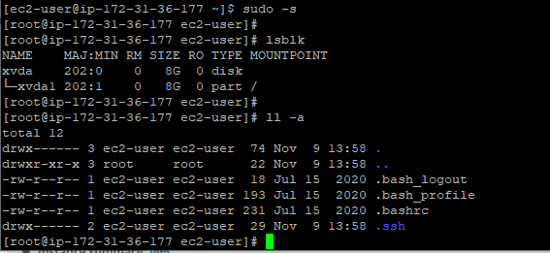

Now we can Stop the ***Linux_Prod_Server*** from AWS console

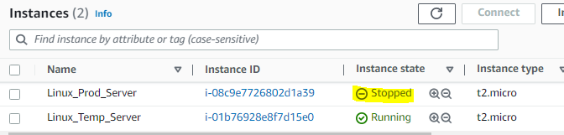

Now we can go to volumes detach the ***Prod_Linux***

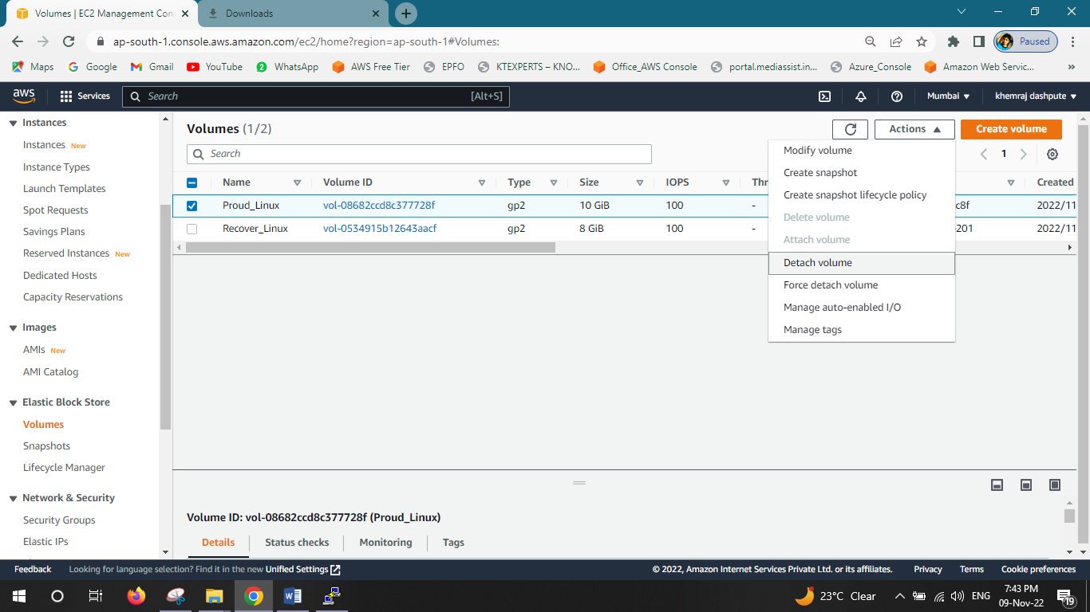

Now Select the same (***Prod_Linux***) and attach to ***Linux_Temp_Server***

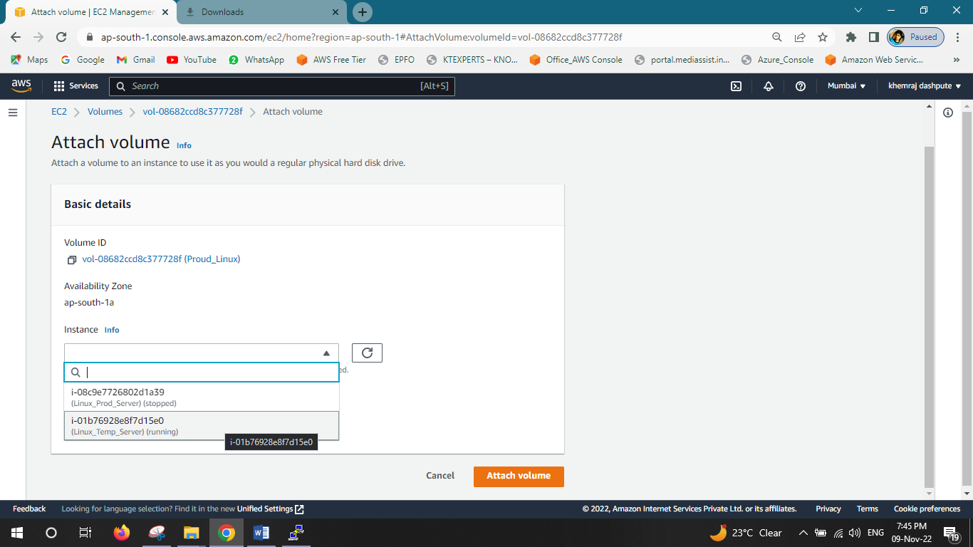

***Attached Done***

Go to Putty

# lsblk –f

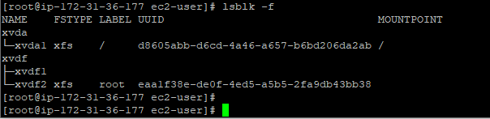

We can see the 2 root volumes in there

Now we need mount the volume with below commands

# lsblk

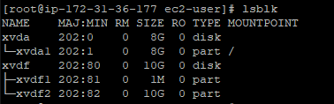

Now we mounting the volume on ***Linux_Temp_Server***

# mount /dev/xvdf2 /mnt

# df -h

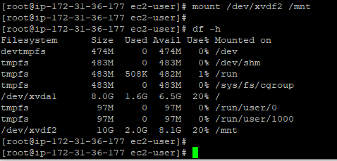

Now we can see the keys for both RecoverKey & GoodKey with below commands

# cat /home/ec2-user/.ssh/authorized_keys RecoverKey

# cat /mnt/home/ec2-user/.ssh/authorized_keys GoodKey

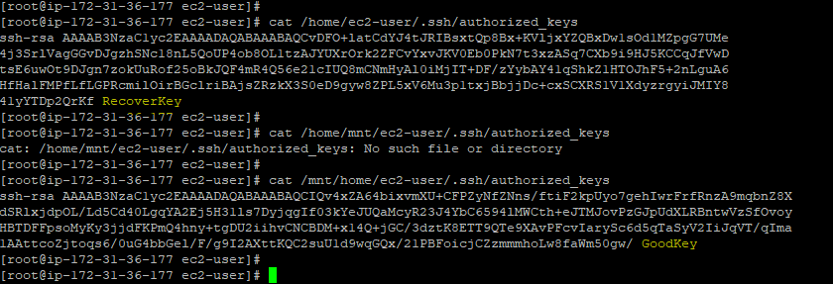

Now we need copy the key with below command (Overwrite)

# cp -p /home/ec2-user/.ssh/authorized_keys /mnt/home/ec2-user/.ssh/authorized_keys

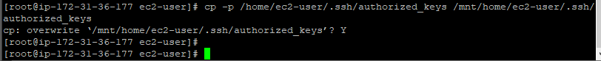

Now we need to unmount

# umount /mnt

# df -h

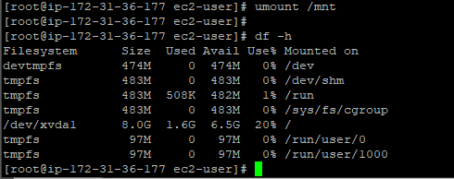

Unmounting Done

Now Go to Volumes & detach the ***Prod_Linux***

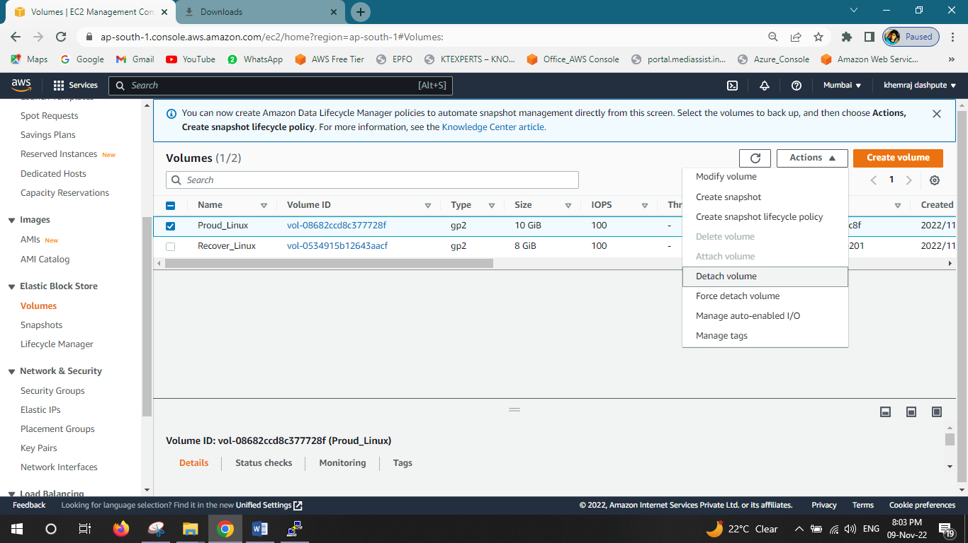

Select the ***Prod_Linux*** & attach to ***Linux_Prod_Server***(Stopped)

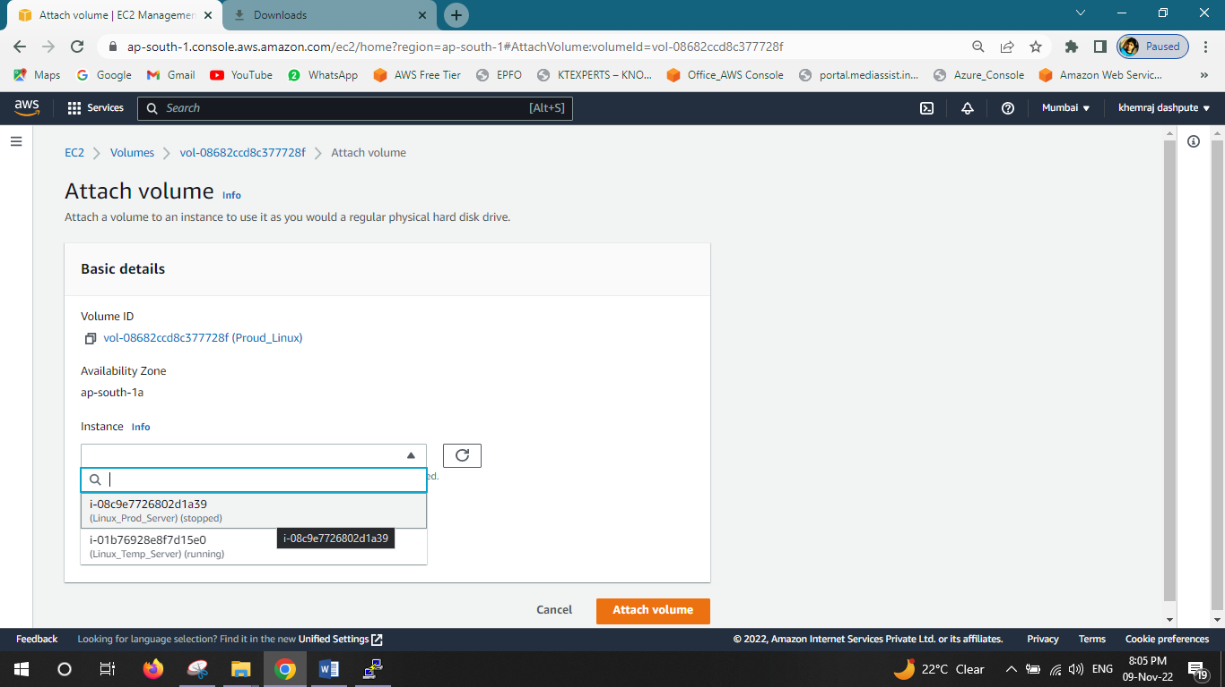

And change the name which we have copied before as - /dev/sda1 – Attach Volume

Now go to ***Linux_Prod_Server*** & start

Copy the Public IP - 35.154.106.203

After start Open the putty & give the Recovery Key to Open the Instance

Run the below commands for check the file & Instance is correct

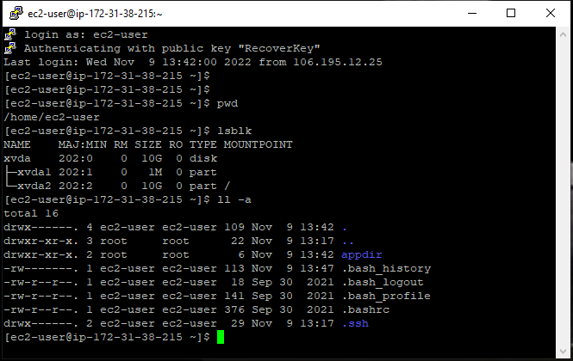# pwd

# lsblk

# ll -a

Instance has been Recover & we can see the appdir